AIM: Setup DirectX 11, Window Framework and Initialize Direct3D Device

INSTALL YOUR UNITY SOFTWARE AFTER INSTALLATION IS SUCCESSFULLY COMPLETED YOU NEED TO SIGNUP (INTERNET REQUIRED)

AFTER LOGIN IN SELECT THE PERSONAL EDITION FOR YOUR INSTALLATION

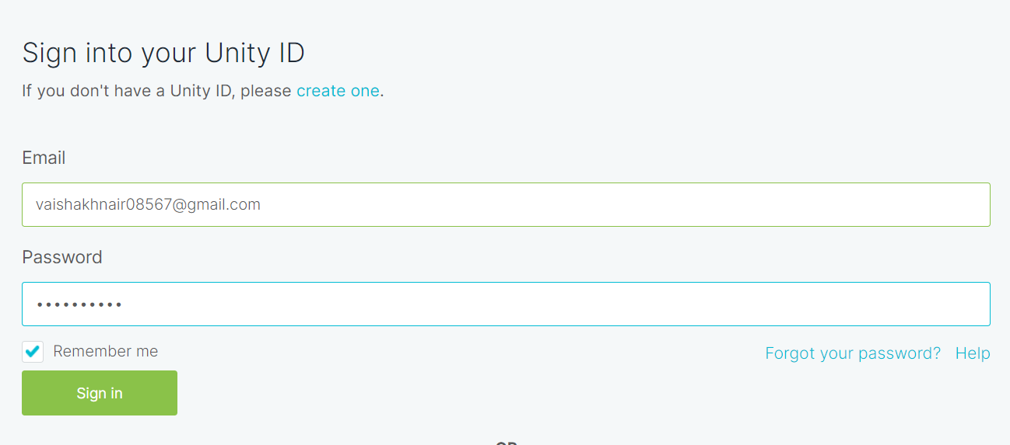

CLICK ON NEXT BUTTON AND CHOOSE THIRD OPTION FROM THE CHOICES

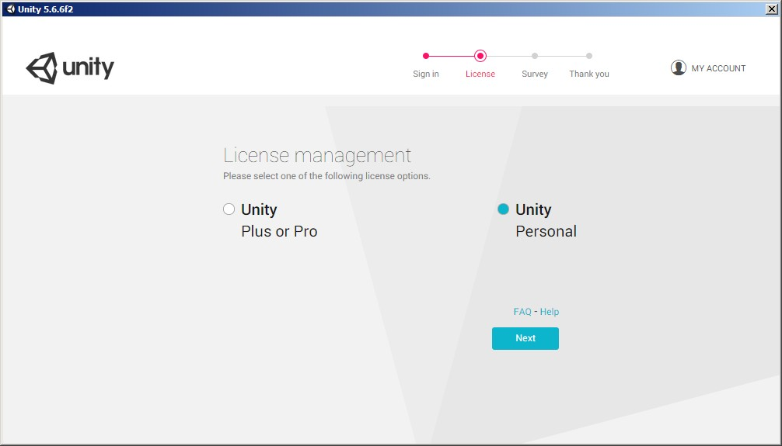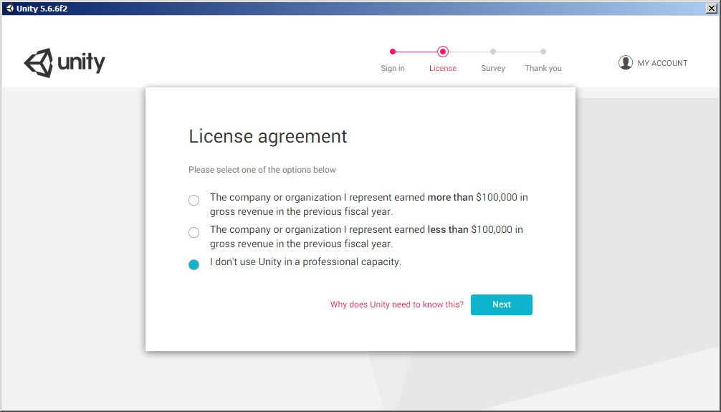

CLICK ON NEXT BUTTON AND U R DONE WITH INSTALLATION PROCESS

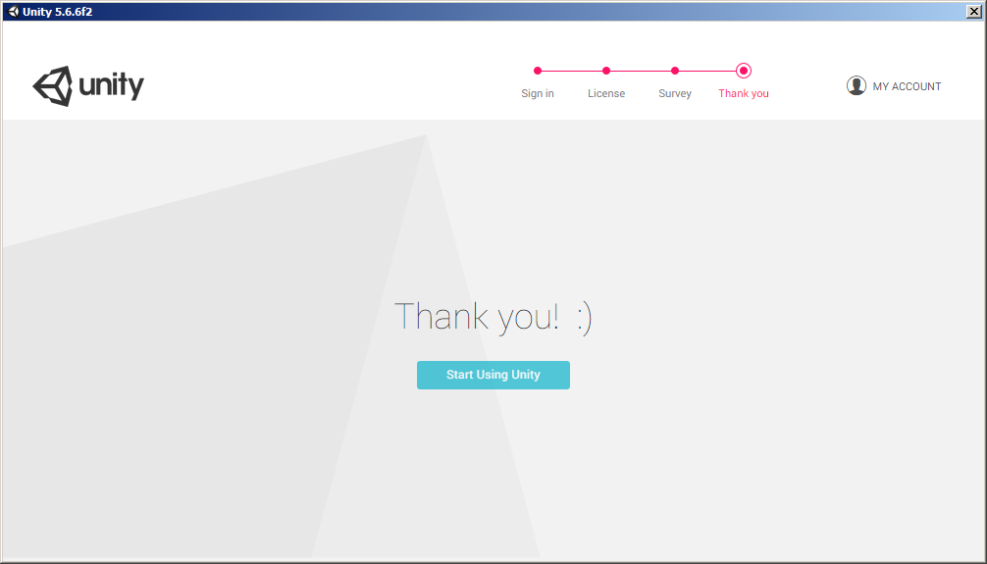

ONCE YOU SUCCESSFULLY LOGIN INTO THE SOFTWARE U CAN WORK IN OFLINE MODE TOO JST SELECT WORK IN OFFLINE MODE

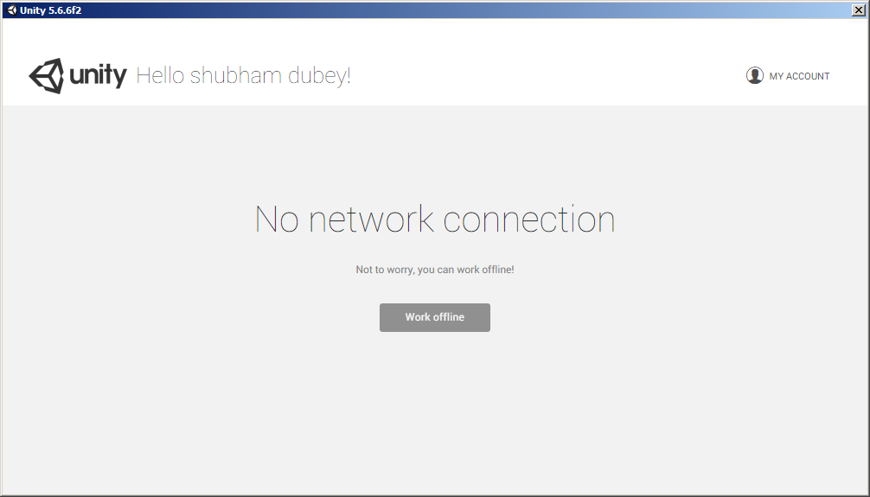

SELECT ON NEW ON UPPER SLIGHTLY LEFT SIDE AND ENTER PROJECT NAME ACCORDINGLY…

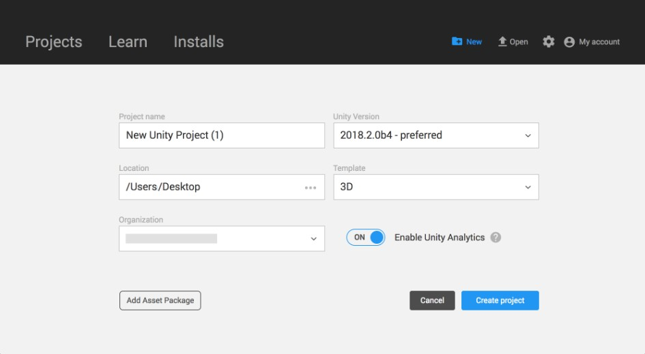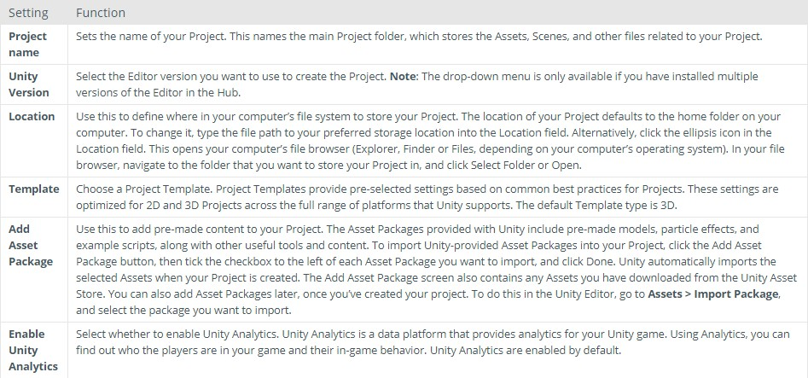

# The Projects tab

On the Home Screen, click **Projects** to view the contents of the **Projects** tab.

CLICK ON EDIT BUTTON AND CHOOSE PROJECT SETTING OPTION ON BOTTON OF BAR AND CLICK ON PLAYER AND A NEW BAR’LL

APPEAR ON RI8 SIDE OF THE SCREEN

# Creating a Project

In the top right corner of the Home Window, click **New** to open the Create Project View.

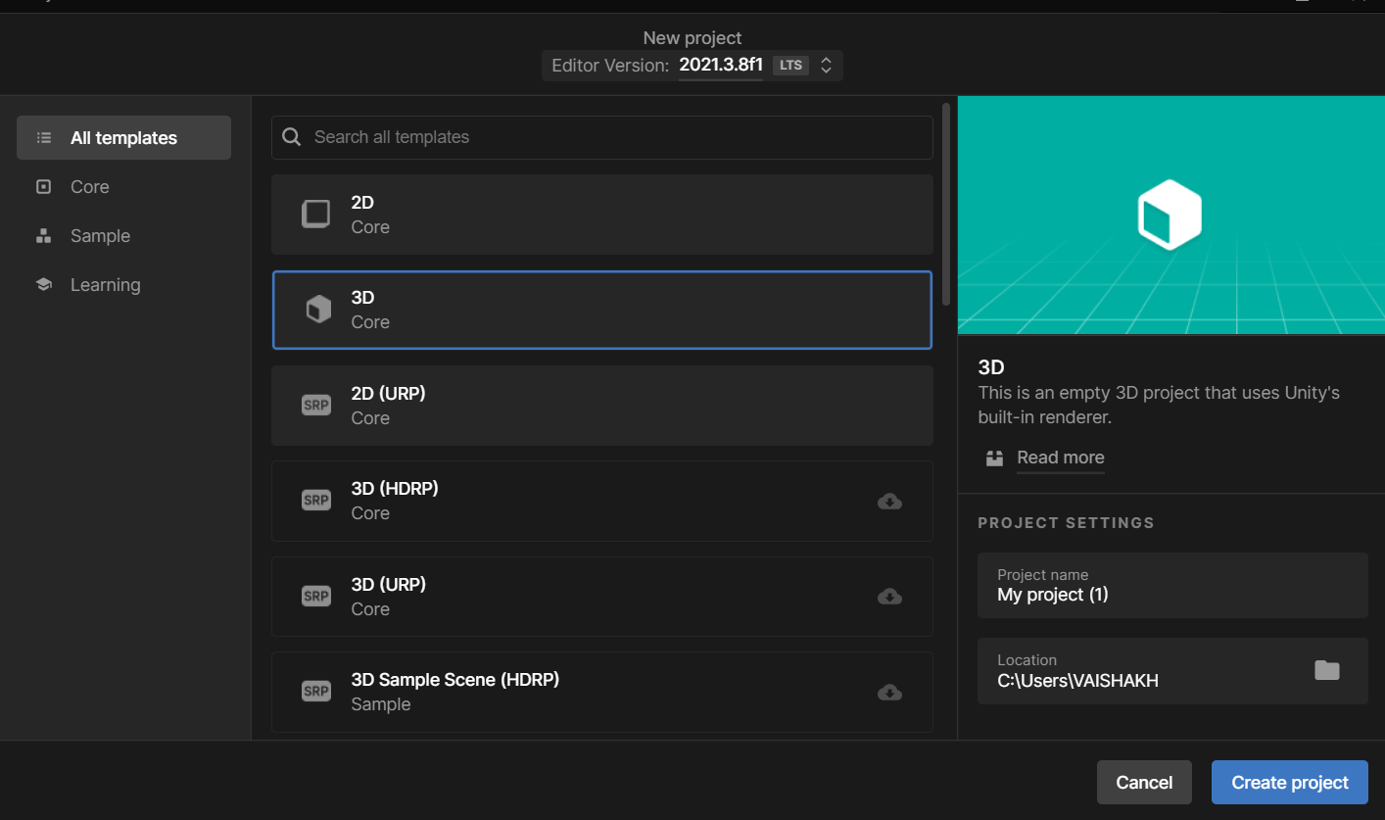

From the Create Project View, there are Project settings to complete before Unity creates your project. These are described in detail below.

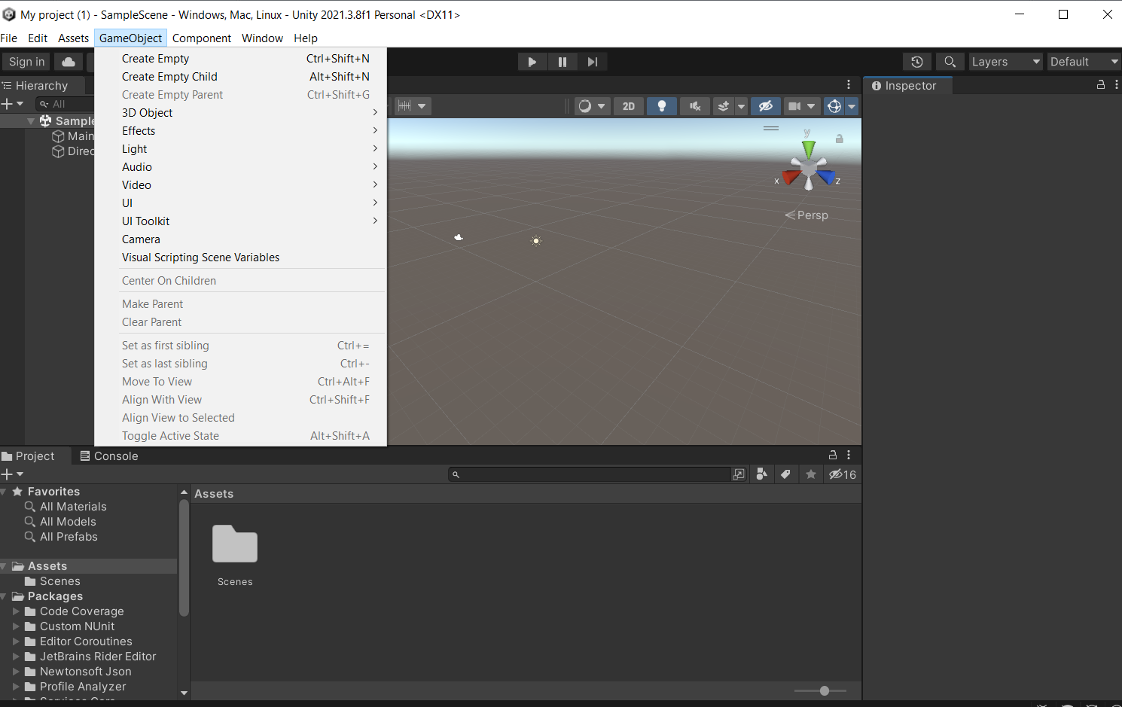

CLICK ON OTHER SETTING AND UNCHECK THE API FOR WINDOWS AND SELECT APPROPIATE DIRECT3D VERSION.

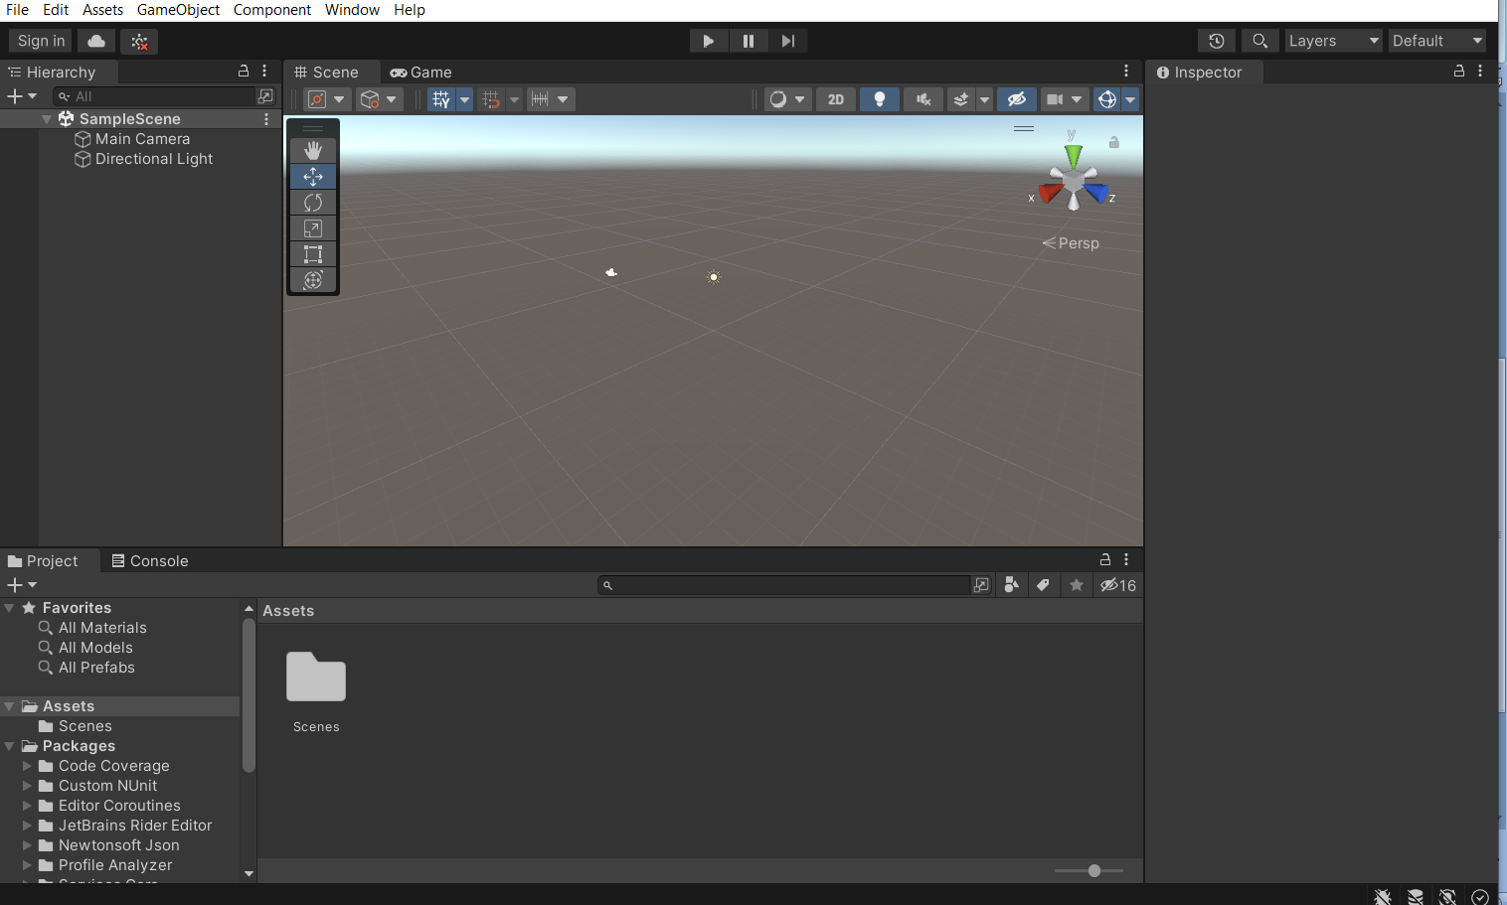

**Practical – 02**

STEP 1: OPEN UNITY CREATE A NEW PROJECT AFTR CREATING PROJECT RIGHT CLICK ON LEFT SIDE OF SCREEN AND CREATE A EMPTY OBJECT.

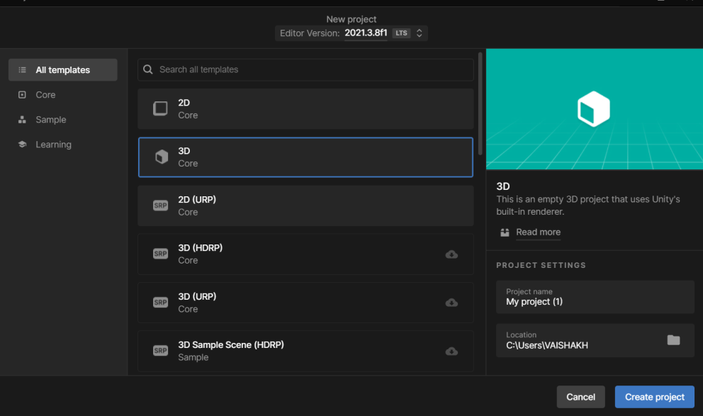

RENAME THE OBJECT ACCORDINGLY....

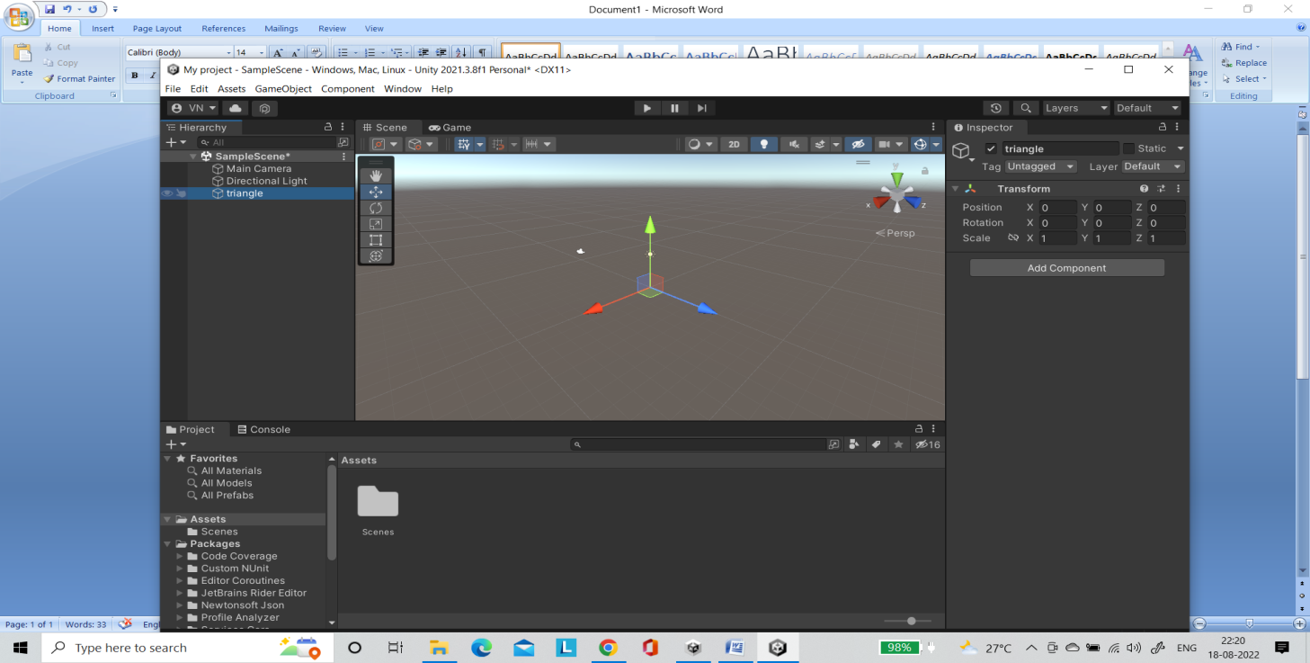

CLICK ON THE OBJECT AND CLICK ON ADD COMPONENTS AND ADD MESH COMPONENTS

SELECT MESH FILTER AND MESH RENDERER ...

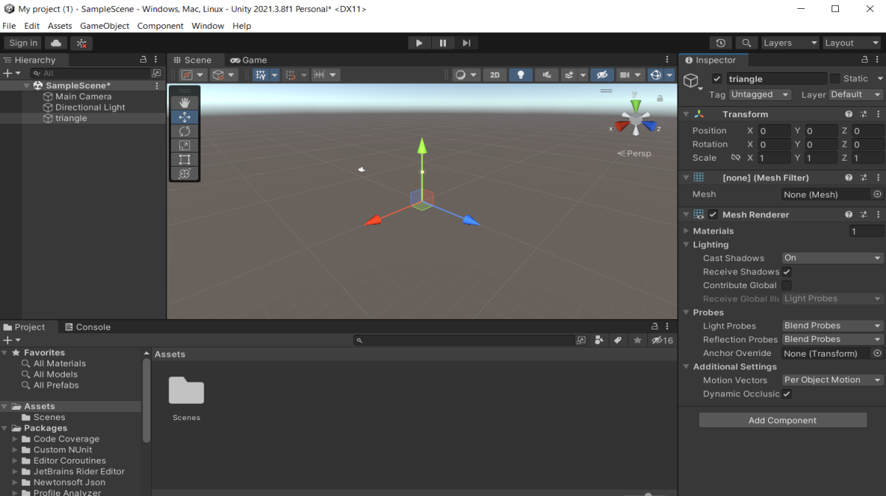

CREATE A ASSET AND SELECT C# SCRIPT

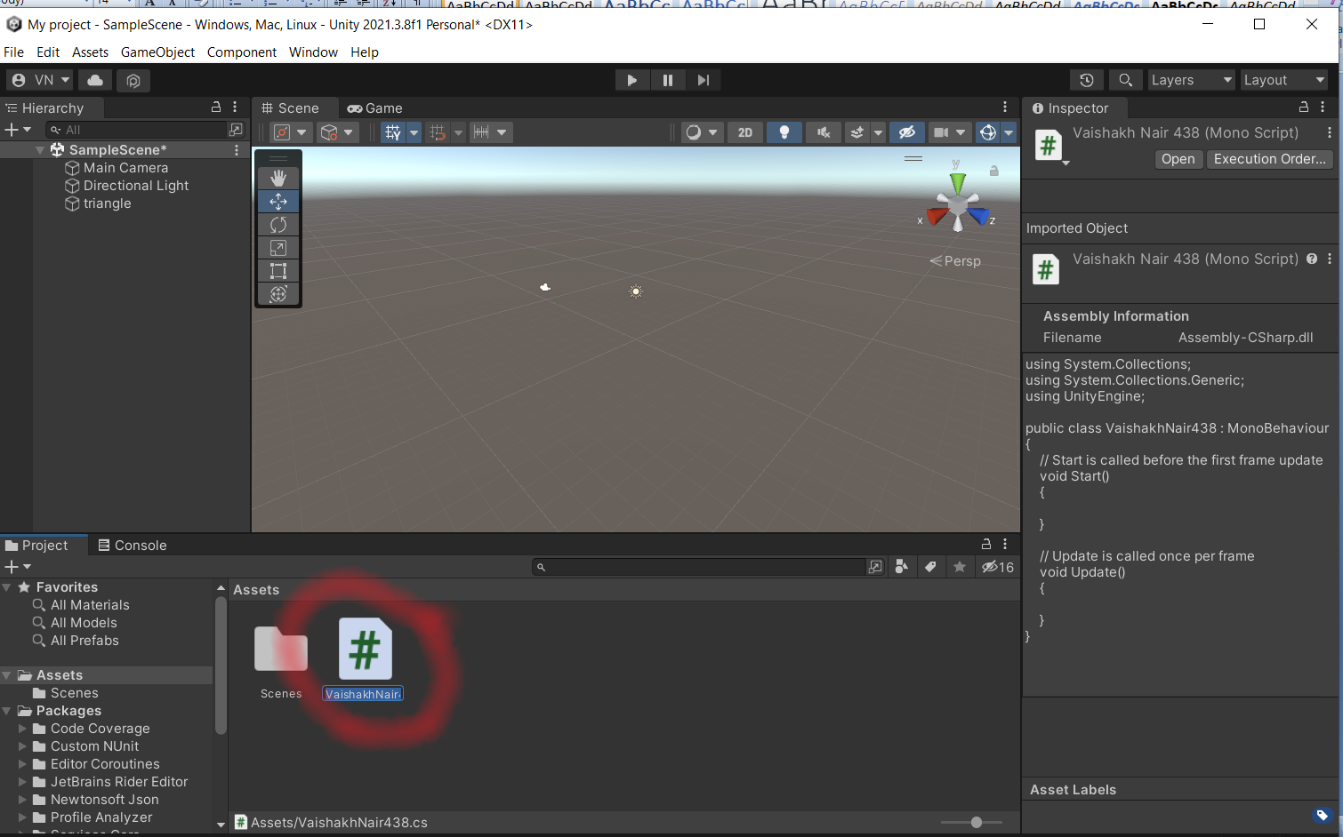

STEP4: Double Click the Asset file and start typing the code given:

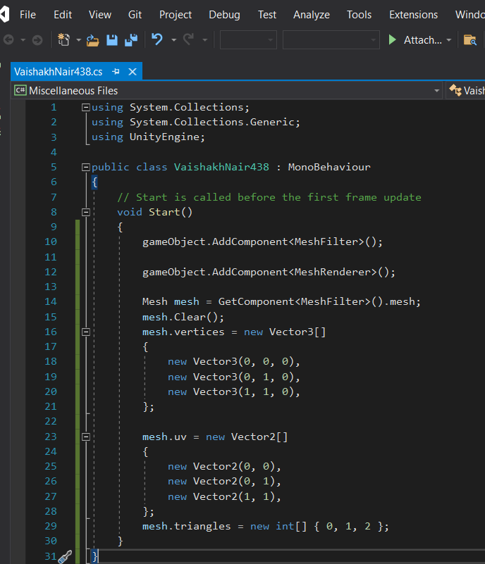

SELECT THE SCALE AND POSITION RESPECTIVE FOR SIZE OF TRIANGLE OR USE MOUSE...

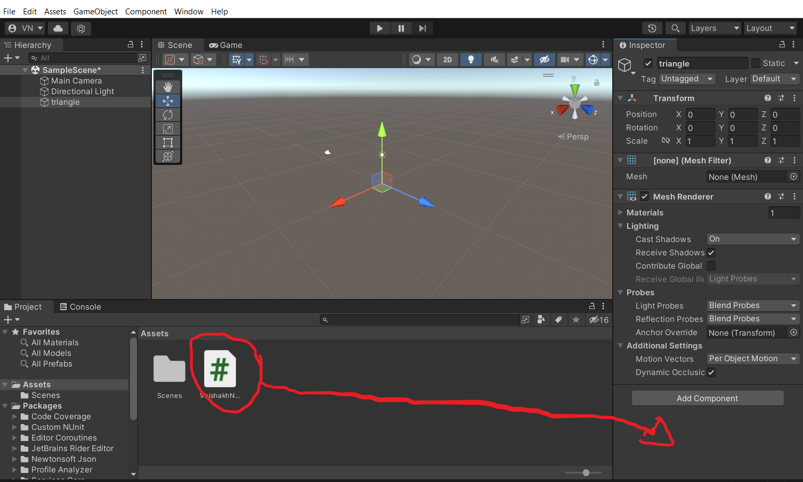

STEP 6 : Run THE APPLICATION

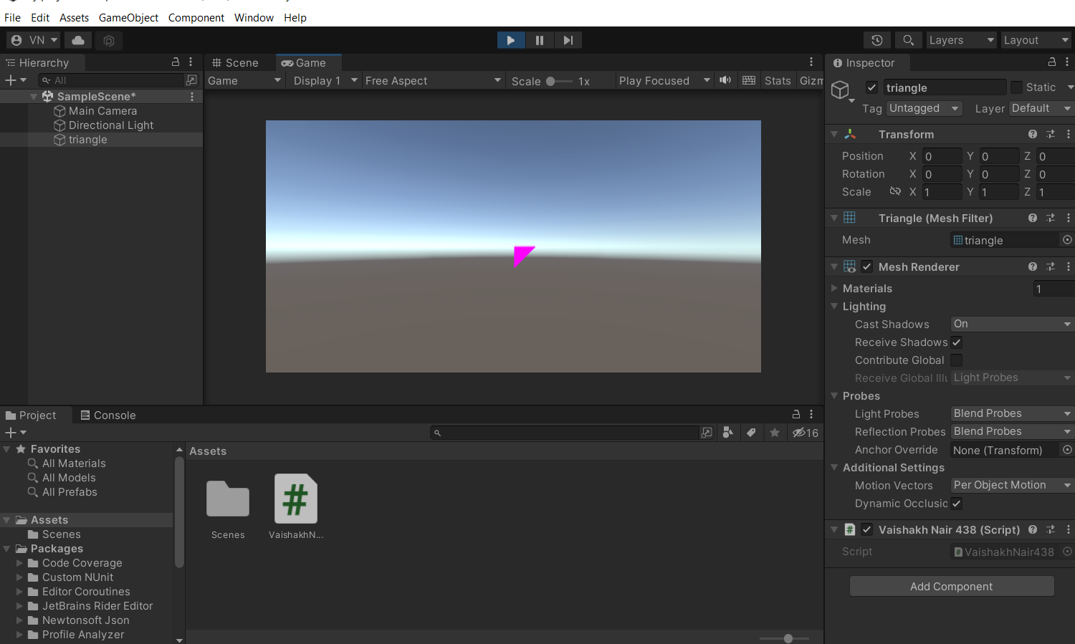

PRACTICAL 3

Step 1

Create a project in 3d core and name it

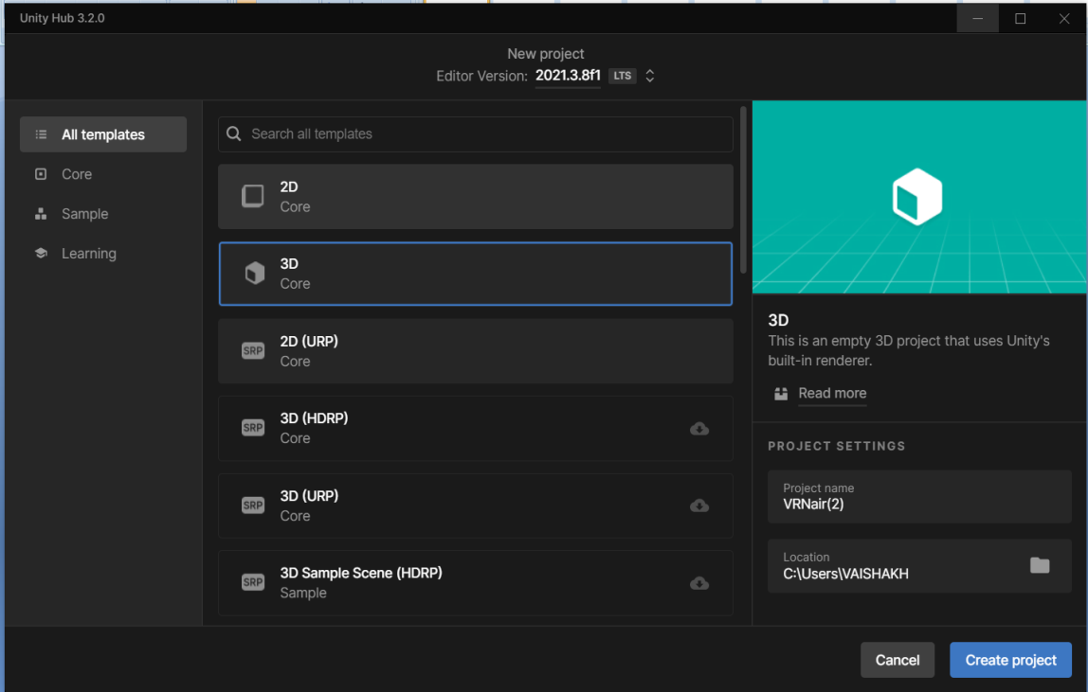

ADD A 3D PLANE TO THE PANEL

GO TO ASSETS CLICK ON CREATE AND THEN ADD MATERIAL

DRAG THE MATERIAL TO THE 3D PANEL AND CHANGE THE COLOUR TO YOUR NEED .

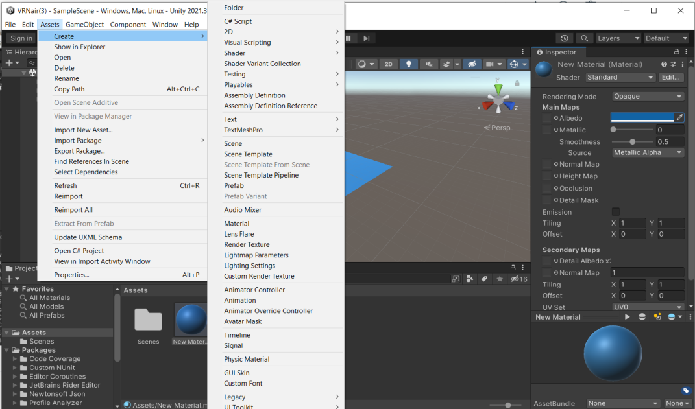

GO TO ASSETS AND IMPORT NEW ASSET

SELECT IMAGE TO YOUR LIKING

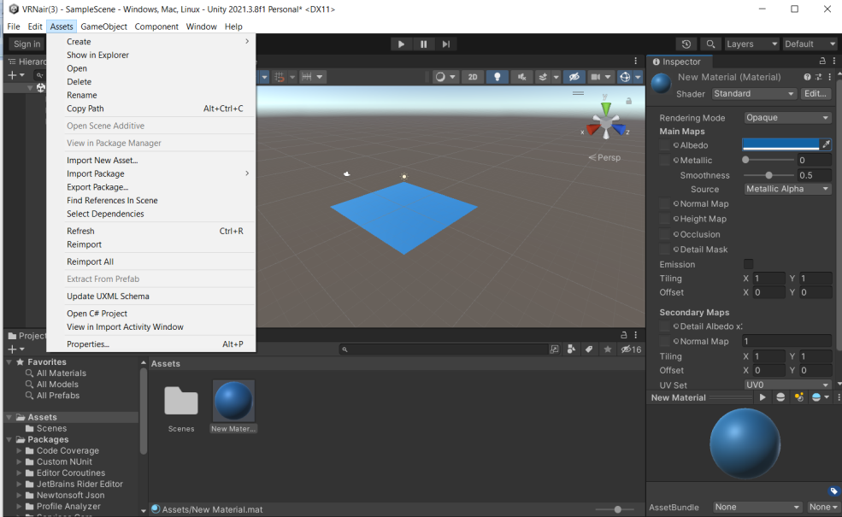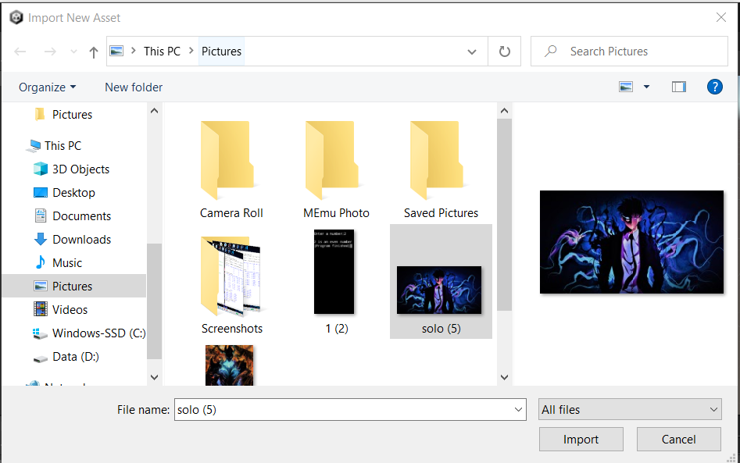

SELECT IMAGE OF ANY KIND

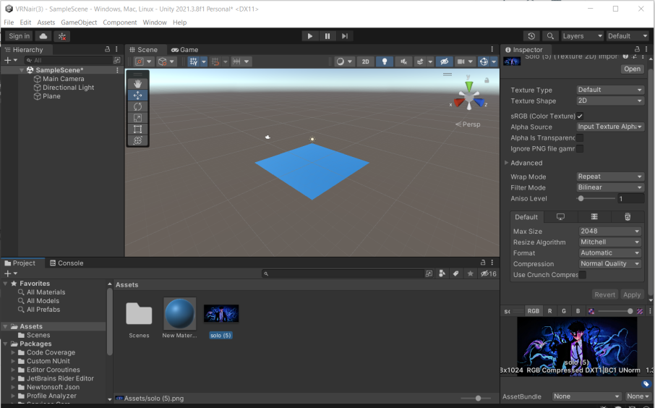

DRAG YOUR IMAGE TO THE PLANE INSIDE

RUN YOUR APPLICATION

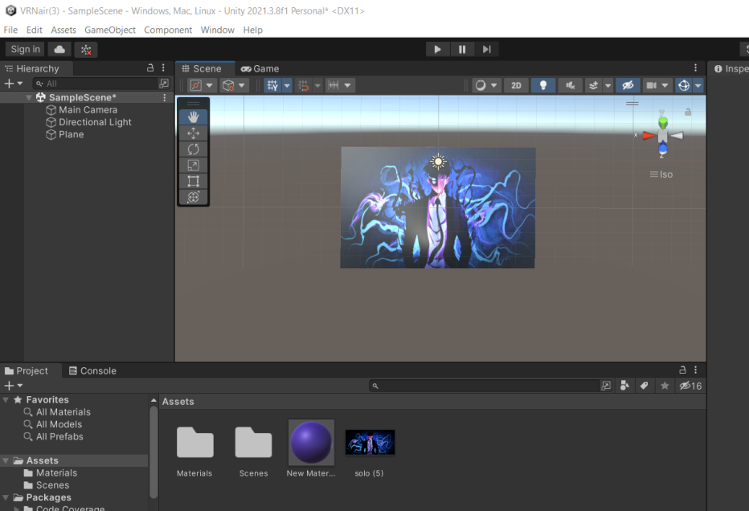

PRACTICAL 4

STEP 1

ADD A 3D PLANE USING GAME OBJECT

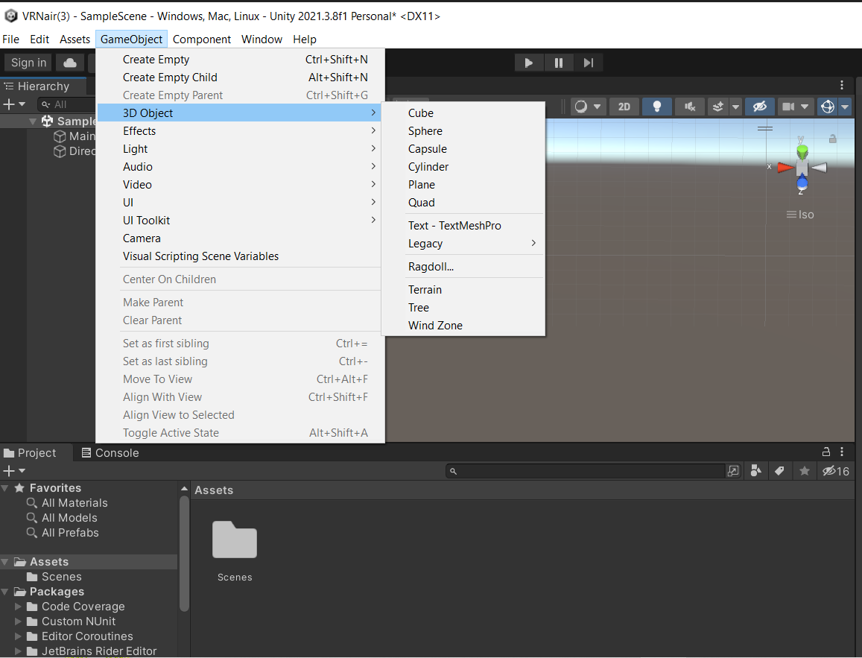

Add a sphere using Game Object

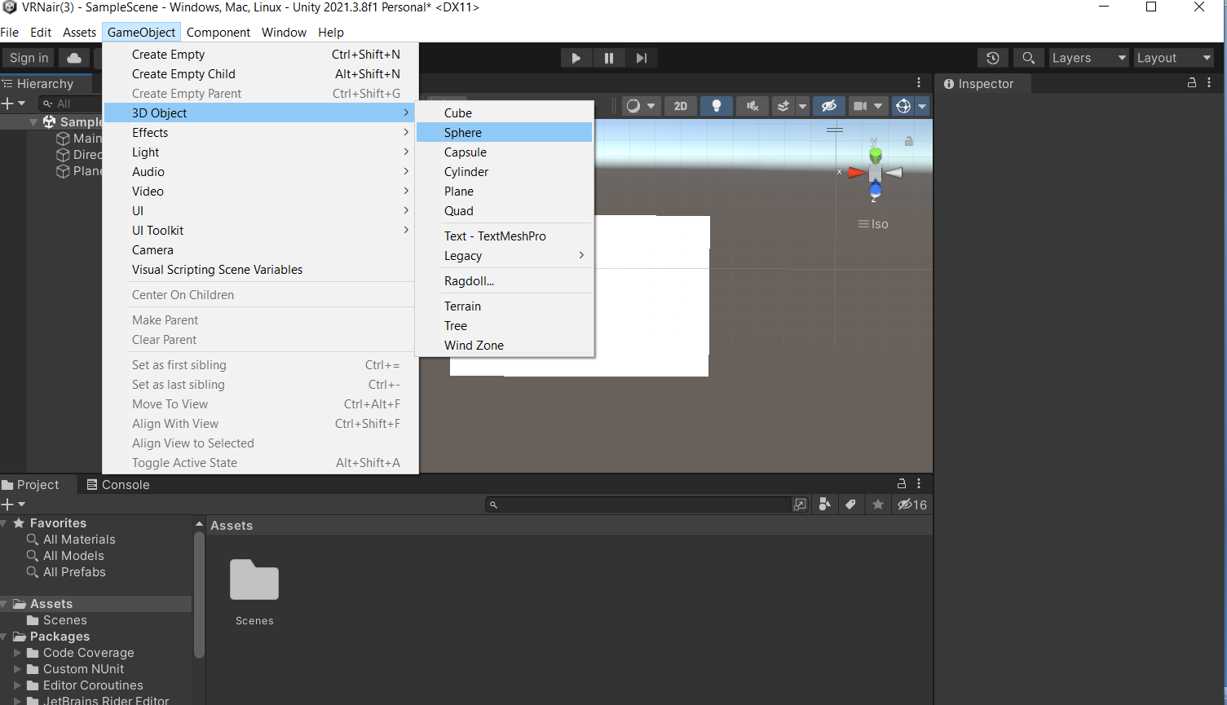

Change sphere Y axis position to “ 2 “ , X =0 , Z = 0

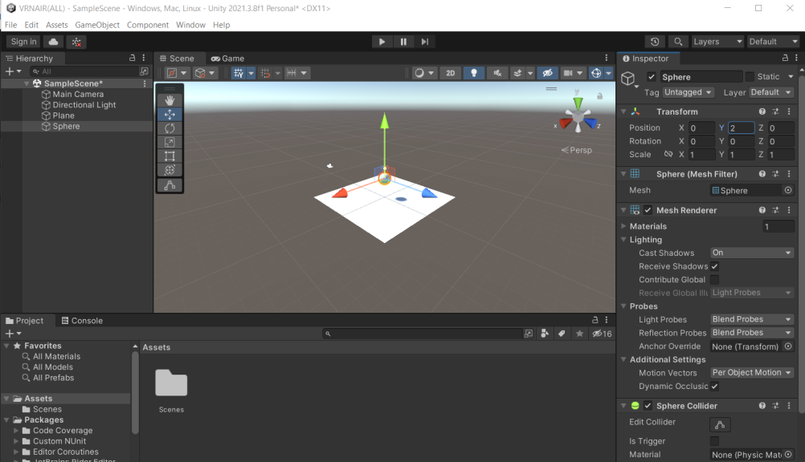

Select Directional light and disable it

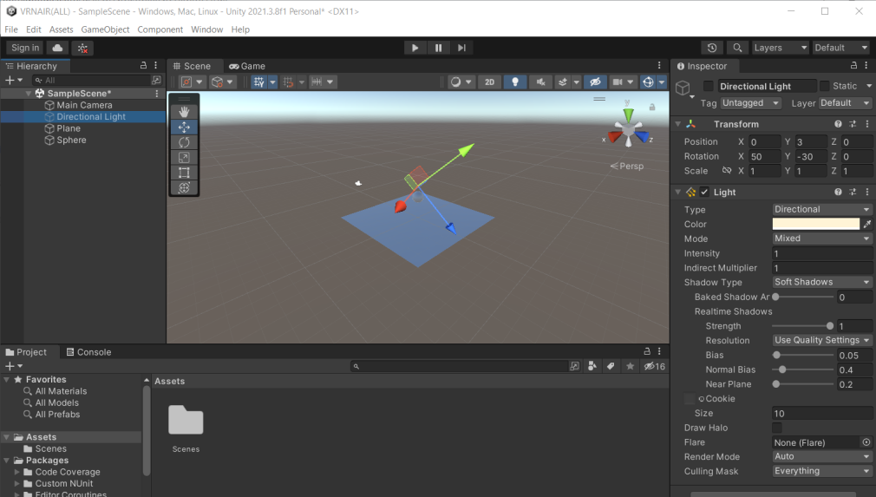

Add a Point Light using Game Object>light

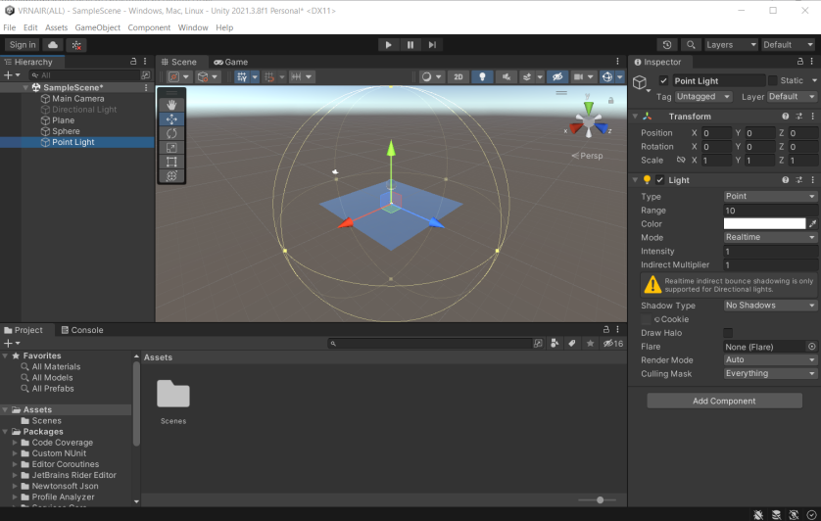

Change point lights position to X =1.5 Y=3 Z=0

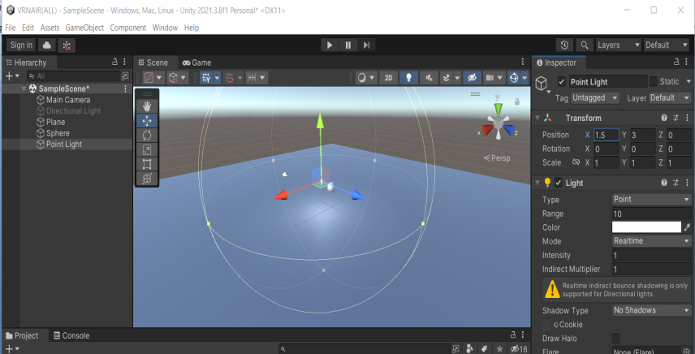

Change point plane’s Scale to X =5 Y=5 Z=5

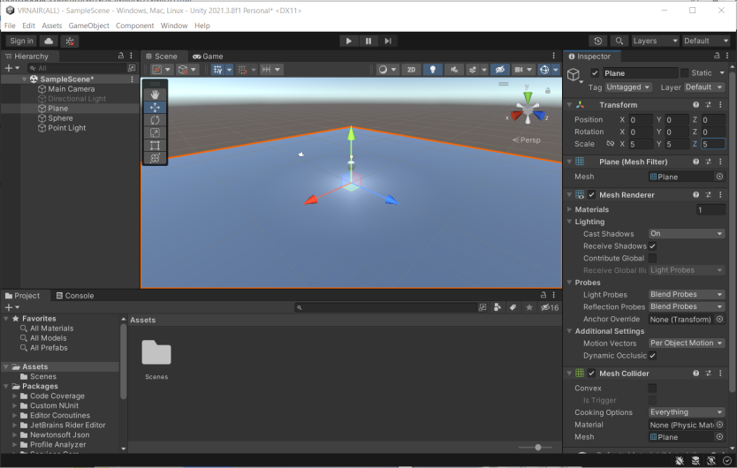

Create a duplicate point light by right clicking on it

Change point light (1) position to X =-1.5 Y=3 Z=0 (MINUS 1.5)

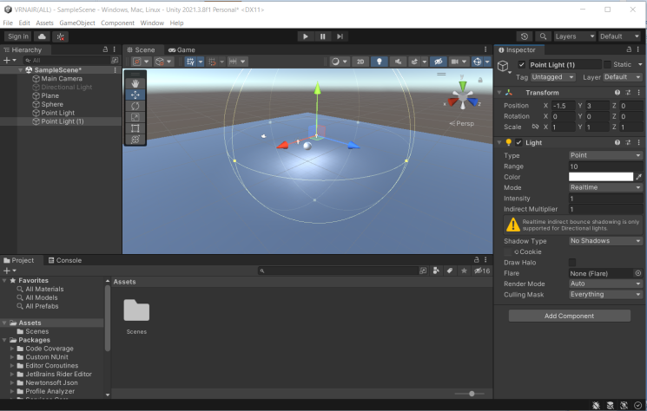

Change the color of light as you like

Go to project window right click > create > c# script

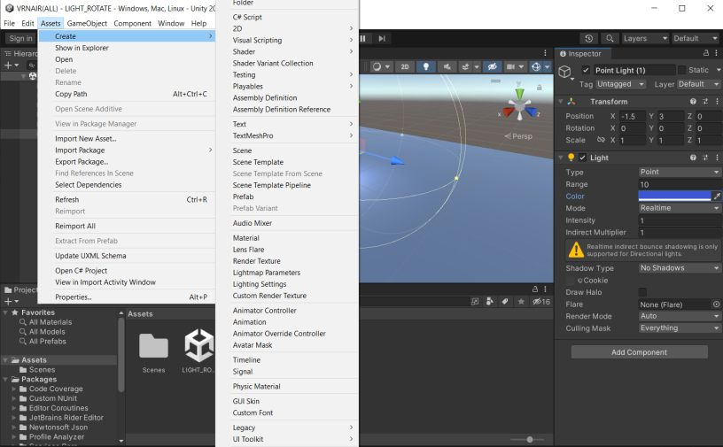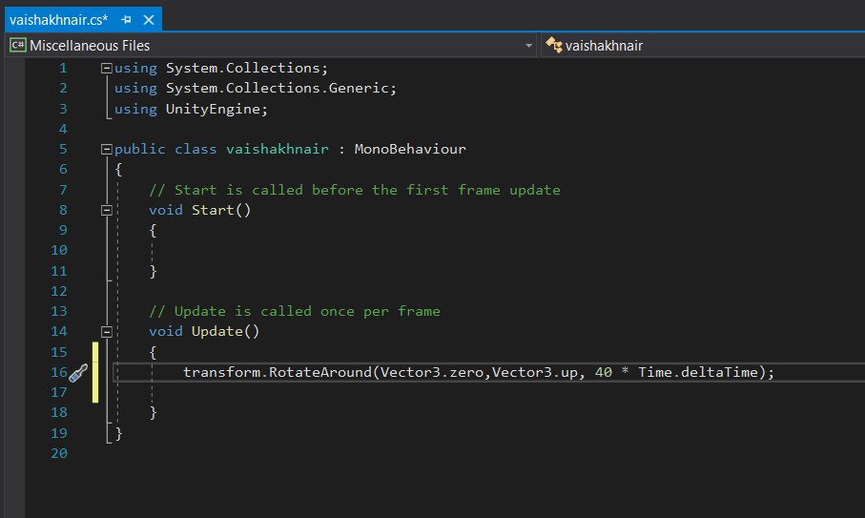

ADD NEWLY CREATED SCRIPT TO POINTLIGHT

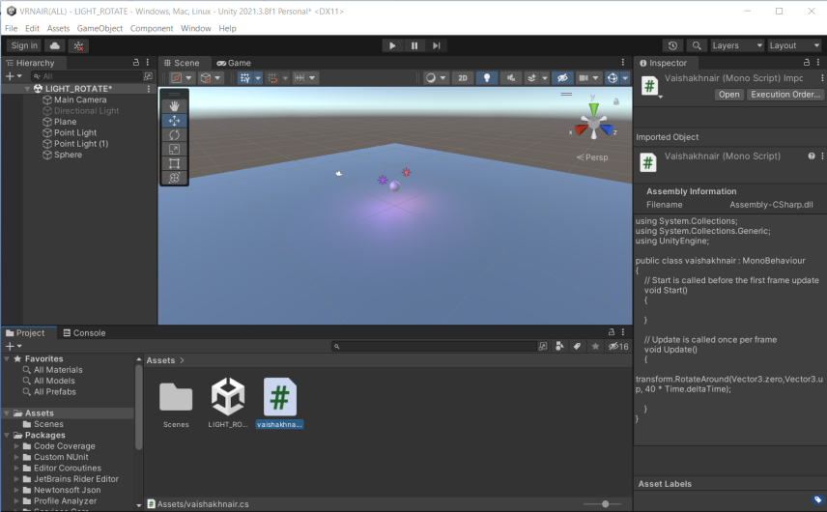

RUN THE APPLICATION :

OUTPUT:

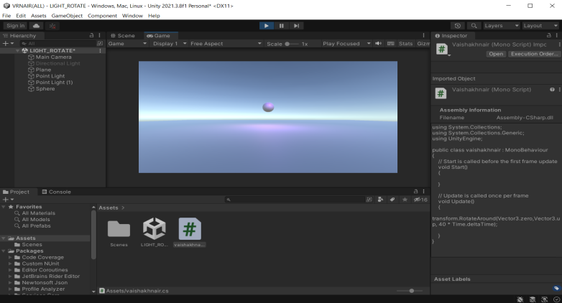

PRACTICAL GP

PRACTICAL 5

OPEN THE PREVIOUS MODEL AND SELECT POINT LIGHT

IN THE RIGHT PANEL CHANGE PAOINT TO SPOT

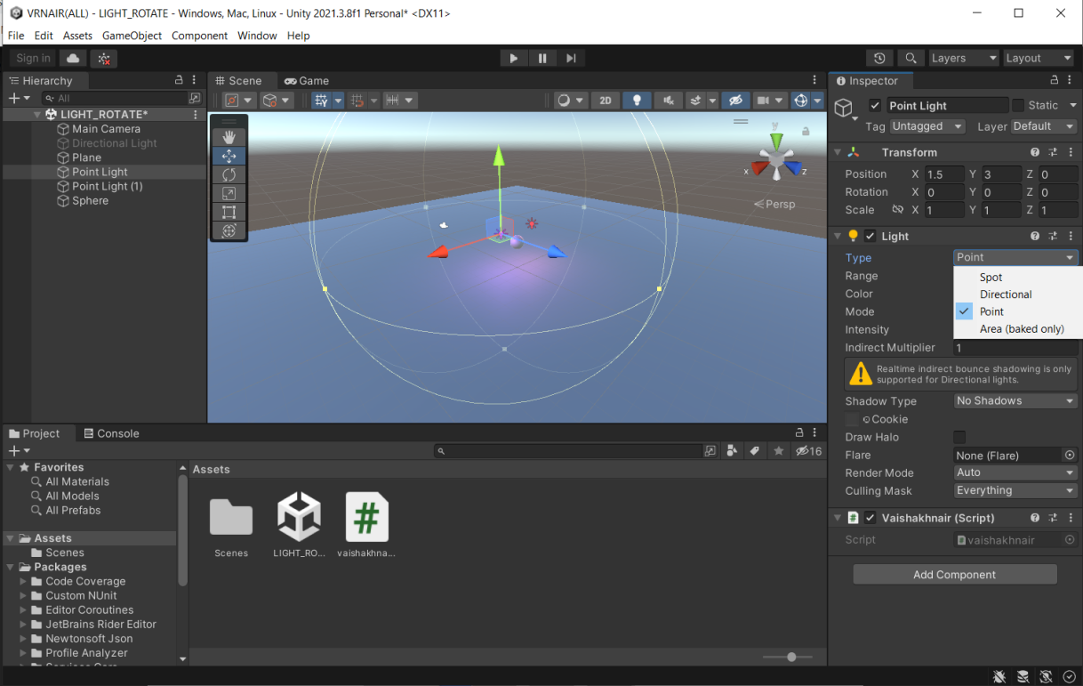

CHANGE THE ROTATION X=90, SPOT ANGLE=80

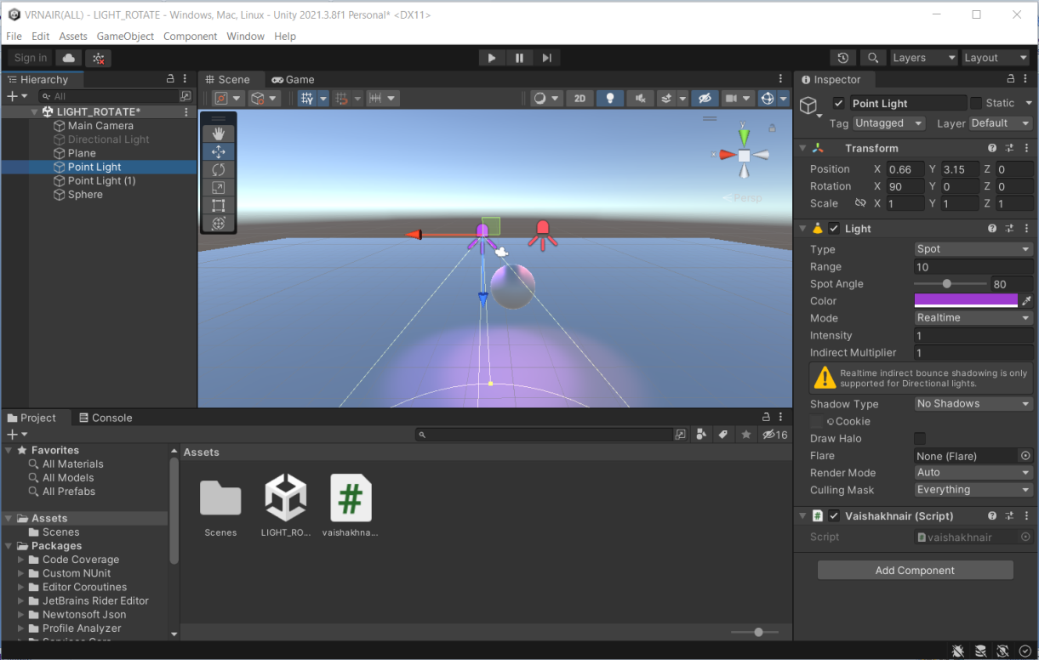

RUN THE APPLICATION

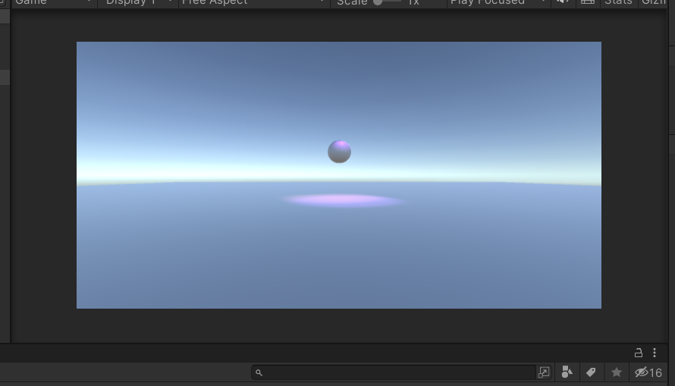

PRACTICAL 6 GP

CREATE A BLANK PROJECT AND IMPORT GIVEN PACKAGES

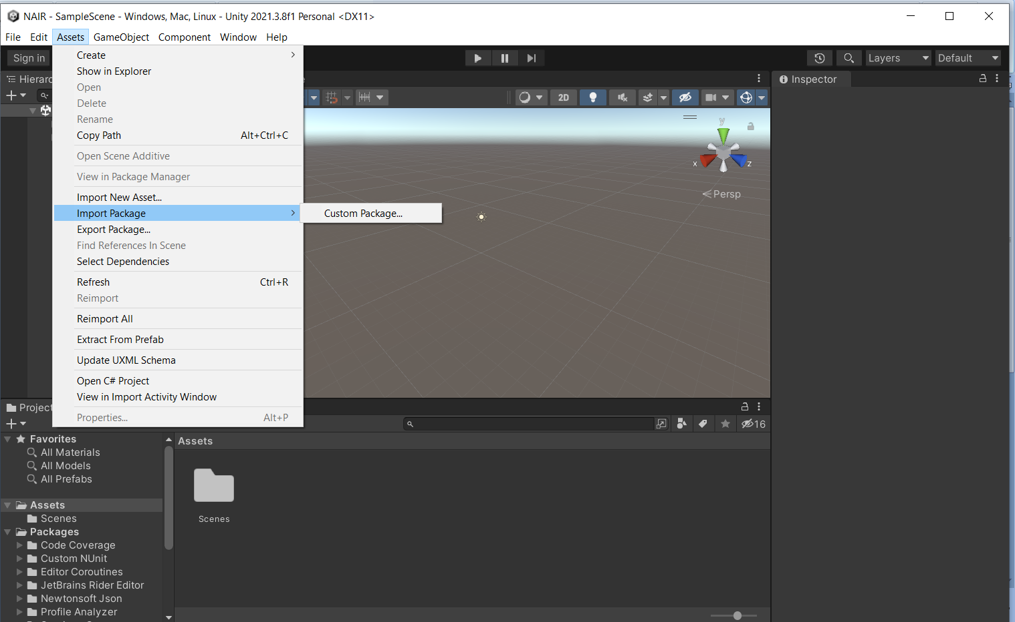

2] Select the package file

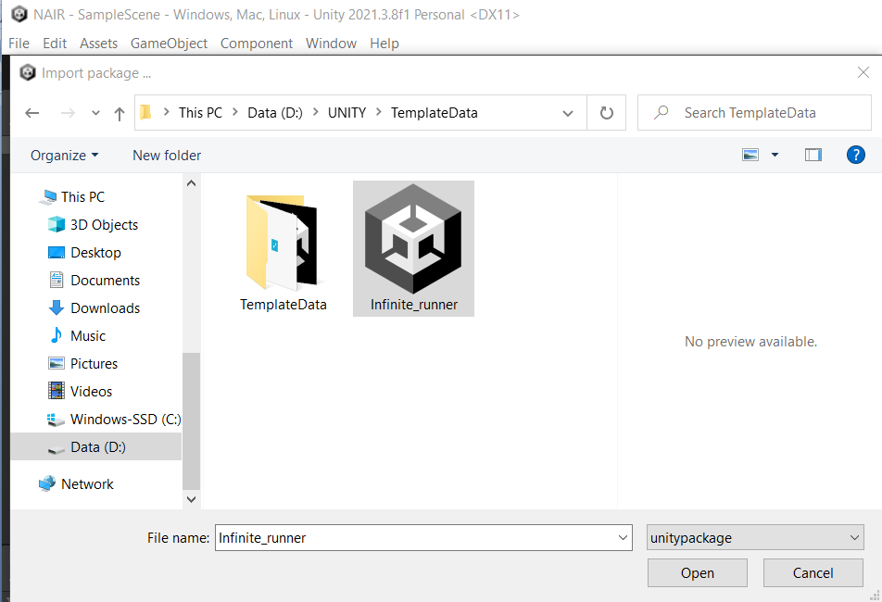

3]IMPORT THE PACKAGE

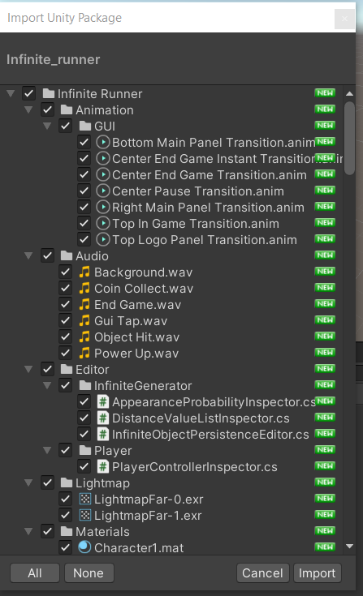

4] GO TO ASSET > INFINITE RUNNER > SCENE>

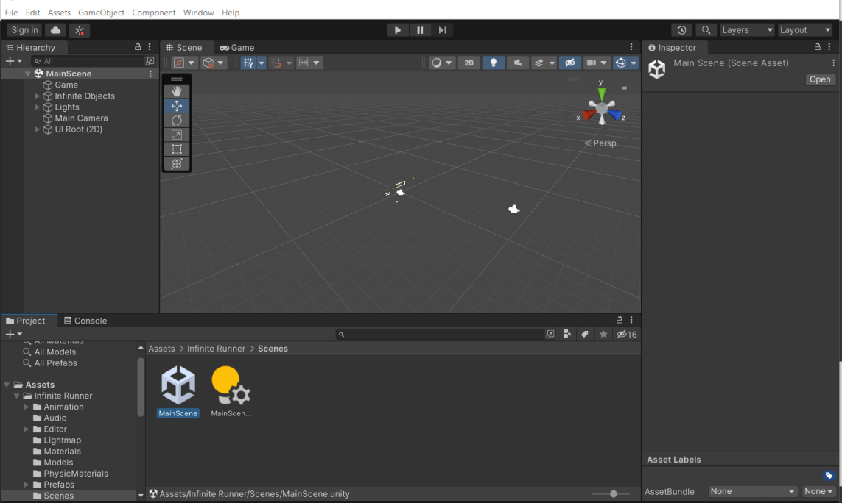

5] RUN THE APPLICATION/GAME

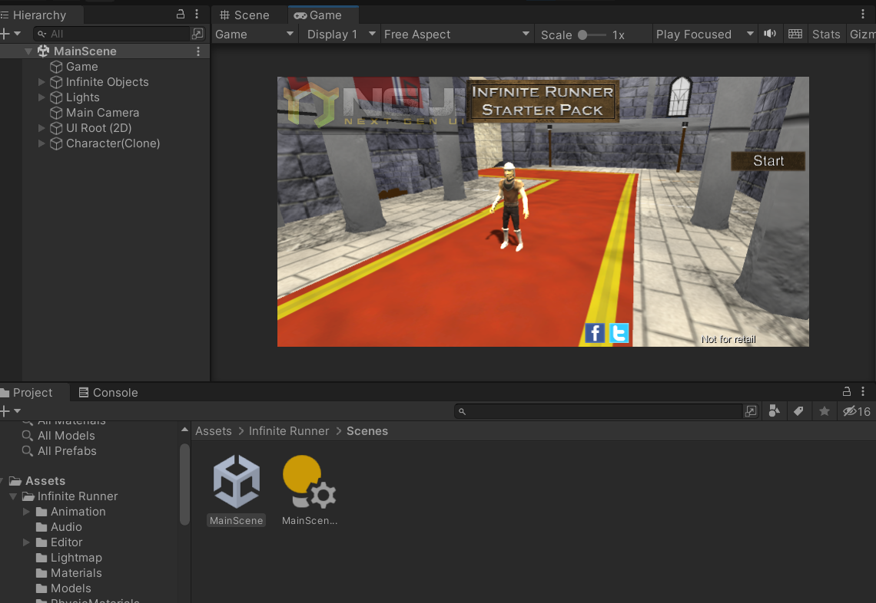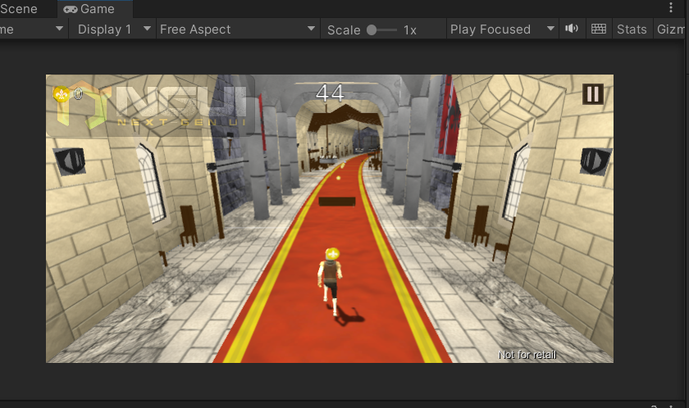

PRACTICAL NO:7

Roll a ball

